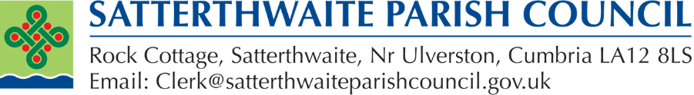

Statement for this year's AGAR 25/26
During this year’s AGAR review, an error was identified in the year-end 2024/25 figures reported on page 6 of the previous AGAR submission. The figures have been corrected in this year’s AGAR to reflect the cash book balances shown on the Council’s Unity Bank statements as at 31 March 2025. As a result, the year-end 31 March 2025 figures shown in the 2024/25 AGAR differ from those shown in the 2025/26 AGAR. These had not been brought to the relevant council meeting by the previous Clerk for checking or signed by the Chair.

The amended figures were reviewed and approved by the Council at its meeting on 8 June 2026 and are considered accurate for both the corrected 2024/25 accounts and the 2025/26 AGAR submission.

The account summaries for 2024/25 and 2025/26, together with both AGAR submissions, are available on the Council’s website.

Any queries should be sent to clerk@satterthwaiteparishcouncil.gov.uk.

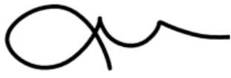

Dr. Caroline Brock
Clerk to Satterthwaite Parish Council

